
Lab Assignment/Task Report
Only for course Teacher
 |  | Needs Improvement | Developing | Sufficient | Above Average | Total Mark
Allocate mark & Percentage |  | 25% | 50% | 75% | 100%
Clarity
Content Quality
Spelling & Grammar
Organization and Formatting
Total obtained mark
Comments

Semester: Fall 2026
Student Name: Tahsin Khanom
Student ID:0022610005101010
Batch: 46 Section:A
Course Code: CSE 124 Course Name: OOP
Course Teacher Name: Debabarata Mallick
Designation: Lecturer
Submission Date: 29/07/2026
1. Hello and Name Printer
Write a Java program to print 'Hello' on screen and your name on a separate line.
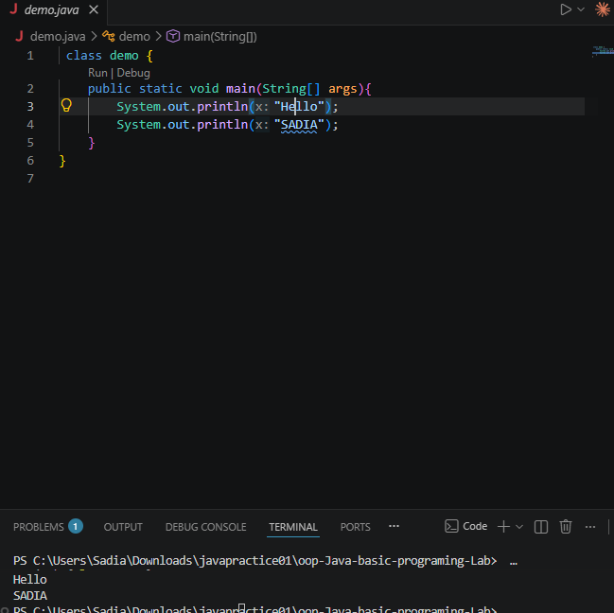
Uses two System.out.println() statements to print "Hello" and the name on separate lines.

2. Sum of Two Numbers
Write a Java program to print the sum of two numbers.
Test Data:
74 + 36
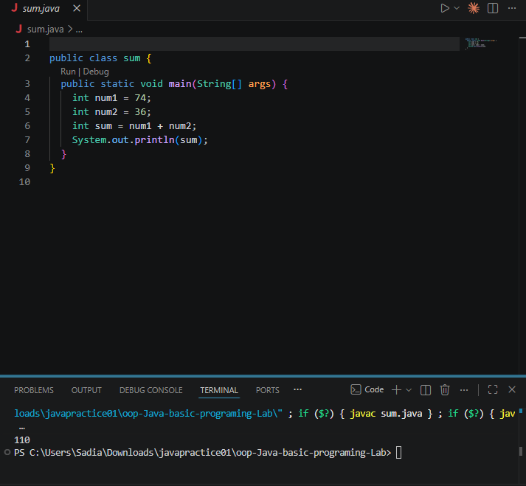
Adds two fixed integers (74 + 36) using the + operator and prints the result.

3. Division of Two Numbers
Write a Java program to divide two numbers and print them on the screen.
Test Data :
50/3
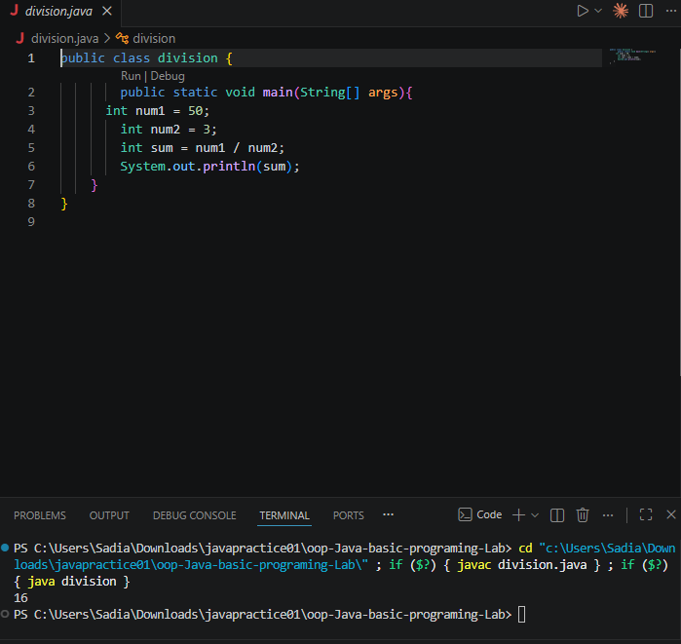
Divides 50 by 3 using integer division (/), which drops the decimal part, giving 16.

4. Arithmetic Operations
Write a Java program to print the results of the following operations.
a. -5 + 8 * 6
b. (55+9) % 9
c. 20 + -3*5 / 8
d. 5 + 15 / 3 * 2 - 8 % 3
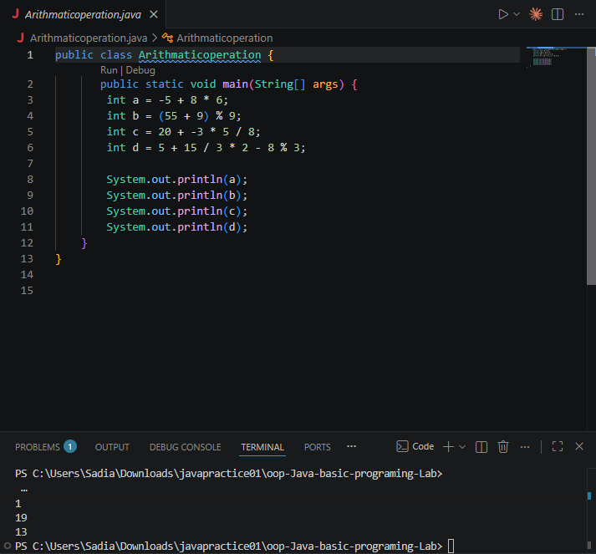
Applies Java's operator precedence rules (*, /, % before +, -, evaluated left to right) to compute each expression's result.
5. Product of Two Numbers
Write a Java program that takes two numbers as input and displays the product of two numbers.

Input first number: 25
Input second number: 5
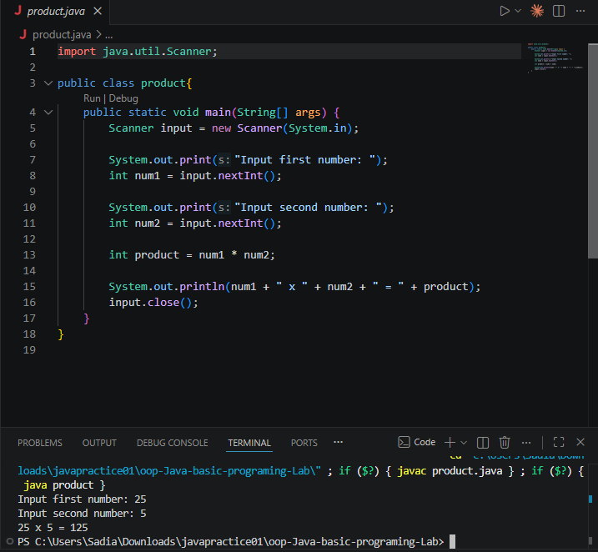
Takes two numbers as user input via Scanner, multiplies them with *, and prints the result in the required format.

